SMART HYBRID CONFERENCES MANAGEMENT PLATFORM
CASE STUDY: RWANDA CONVENTION BUREAU

By
BY UMUTWARE NICOLAS
2205000007

A RESEARCH PROPOSAL SUBMITTED TO THE UNIVERSITY OF KIGALI IN PARTIAL FULFILLMENT OF THE REQUIREMENTS FOR THE AWARD OF BACHELOR’S DEGREE IN SCHOOL OF COMPUTING AND IT

July, 2026

DECLARATION
This dissertation is my original work and has not been submitted previously for a degree at this or any other university/institute. To the best of my knowledge, it does not contain any material published or written by another person, except as acknowledge in the text.

Signature……………………………. Date……. / …… / ……

UMUTWARE Nicolas

APPROVAL

This is to Confirm that I have received and approved the submission of this dissertation. It meets the necessary requirements for submission

Signature……………………………. Date……. / …… / ……

MR MANIRARORA Jean Marie Vianney

DEDICATION
This work is dedicated to My parents Their support and belief in abilities have motivated me to persevere throughout my educational journey. I also dedicate this work to my whole family, friends and all who helped, encouraged and motivated me to pursue my goals with determination and confidence. Above all I dedicate this work to Almighty God for His blessings and protection throughout my studies and during the preparation of this proposal.

ACKNOWLEDGEMENT
I offer my special thanks to almighty God who guided me through this period.
I extend sincere appreciation in thanking all my lectures, HOD’s, Dean and other complimentary departments of University of Kigali, especially those in BBIT Department who I collaborated with constantly for their contribution throughout this whole period.
Special thanks go to my Supervisor MANIRARORA JEAN MARIE VIANNEY who spent this time and effort committed to guiding me in implementing my ideas into real-work and problem-solving solutions. I also thank my friends for their motivations which motivated me in this period.
And gratitude goes to my classmates at University of Kigali whom we collaborated constantly and we ensure that our learning experience is fruitful. I fill owning big dept to my family who provided every and any type of help, all needs, school fees and my support which all of that was for succeed in my education.
My almighty God blees you all!

ABSTRACT

The conference and events industry have undergone significant transformation due to advancements in information and communication technologies, globalization, and the increasing demand for remote participation. Traditional conference management approaches, which primarily focus on physical attendance, are no longer sufficient to meet the needs of modern participants. As a result, hybrid conferences, which combine physical and virtual participation, have emerged as an effective solution for expanding audience reach, enhancing engagement, and improving accessibility.
This project presents the design and development of a Smart Hybrid Conference Management Platform for Rwanda’s Event Industry. The primary objective of the study is to develop an integrated web-based platform that enables efficient planning, management, and monitoring of hybrid conferences by combining essential conference management functions into a single system. The platform is designed to support attendee registration, event scheduling, live streaming integration, virtual participation, audience interaction, networking opportunities, and analytical reporting. In addition, the proposed system incorporates features that promote Rwanda’s tourism sector by providing conference participants with information about local attractions, accommodation facilities, transportation services, and cultural experiences.
The study employed the Agile Software Development Methodology to ensure continuous stakeholder involvement and iterative system improvement throughout the development process. Data were collected through literature reviews, questionnaires, interviews, and observations involving event organizers, conference participants, and other stakeholders in Rwanda’s events industry. The research further established the need for a centralized platform capable of managing both physical and virtual attendees while providing real-time insights to event organizers.
The study concludes that the implementation of a Smart Hybrid Conference Management Platform can significantly improve the efficiency, accessibility, and effectiveness of conference management within Rwanda’s growing events industry.
Keywords: Hybrid Conference Management, Event Management System, Virtual Attendance, Live Streaming, Audience Engagement, Analytics Dashboard, Digital Transformation

TABLE OF CONTENTS
Table of Contents
DECLARATION I
APPROVAL II
DEDICATION III
ACKNOWLEDGEMENT IV
ABSTRACT V
TABLE OF CONTENTS VI
TABLE OF FIGURE VIII
LIST OF TABLES IX
LIST OF ABBREVIATIONS X
CHAPTER ONE: GENERAL INTRODUCTION AND BACKGROUND TO THE STUDY 1
1.0 Introduction 1
1.1 Background of the Study 1
1.2 Statement of the Problem 2
1.3 Objectives of the Study 2
1.3.1 General Objective 2
1.3.2 Specific Objectives 2
1.4 Research Questions 3
1.5 Significance/Importance of the study 3
1.5.1 To Event Organizers 3
1.5.2 To Conference Attendees and Participants 3
1.5.3 To Rwanda's Conference and Events Industry 3
1.5.4 To the Tourism Sector 4
1.5.5 To Government and Policy Makers 4
1.5.6 To Society 4
1.6 Scope of the Study 4
1.6.1 Content Scope 4
1.6.2 Geographical Scope 5
1.6.3 Time Scope 5
1.7 Limitations of the Study 5
CHAPTER TWO: LITERATURE REVIEW 6
2.0 Introduction 6
2.1 Definition of Key Terms 6
2.2 The Body of the Literature Review 8
2.2.1Empirical Review 8
2.2.2 Theoretical Review 10
2.2.3 Summary of the Gap 14
2.2.4 Conceptual Framework 15
CHAPTER THREE: RESEARCH METHODOLOGY 19
3.0 Introduction 19
3.1 Research Design 19
3.2 Population and Selection of the sample 19
3.2.1 Target Population 20
3.2.2 Sampling selection 21
3.3 Tools for Data Collection and Instrumentation 22
3.4 Collection of data 22
3.5 Presentation of data and Analysis of data 23
3.6 Validity and Reliability 25
3.7 Ethical Considerations 25
REFERENCES 27

TABLE OF FIGURE

Figure 1 29
Figure 2 38
Figure 3 39

LIST OF TABLES

Table 1 32
Table 2 33

LIST OF ABBREVIATIONS

AI: Artificial Intelligence
ICT: Information and Communication Technology IS: Information System
IT: Information Technology
MICE: Meetings, Incentives, Conferences and Exhibitions TAM: Technology acceptance Model
UTAUT: Unified Theory of Acceptance and Use of Technology UX: User Experience
URL: Uniform Resource Locator WLAN: Wireless Local Area Network LAN: Local Area Network
DBMS: Database Management System SQL: Structured Querry Language PHP: Hypertext Preprocessor
KPI: Key Performance Indicator

CHAPTER ONE: GENERAL INTRODUCTION AND BACKGROUND TO THE STUDY

1.0 Introduction
The conference and events industry have undergone remarkable transformation due to advances in information and communication technologies. Hybrid conferences combine physical and virtual participation, enabling wider access and engagement. Rwanda has invested in conference infrastructure and digital innovation to position itself as a major destination for international events. Conferences, summits, exhibitions, workshops, and business forums provide opportunities for networking, professional development, investment promotion, and policy discussions. The rapid growth of digital technologies has transformed how events are organized and delivered, resulting in the emergence of hybrid events that combine physical attendance with virtual participation. This study therefore proposes the design and development of a Smart Hybrid Conference and Event Management Platform: A Case Study of the Rwanda Convention Bureau (RCB). The proposed platform seeks to integrate online registration, event scheduling, hybrid participation, live streaming, attendee engagement, networking, analytics, reporting, and tourism information into a centralized system. The platform is expected to improve conference management processes at RCB by enhancing operational efficiency, increasing participant satisfaction, supporting informed decision-making, and strengthening Rwanda's position as a leading conference and MICE destination in Africa.

1.1 Background of the Study

Globally, conference management evolved from manual processes to digital platforms supporting registration, scheduling, communication, and analytics. The growth of virtual and hybrid events demonstrated the need for integrated technologies. In Africa and Rwanda, event organizers increasingly depend on digital solutions, yet many still use fragmented systems. A centralized Smart Hybrid Conference Management Platform can improve efficiency, accessibility, engagement, and performance monitoring. Globally, conference management evolved from

1.2 Statement of the Problem

The Rwanda Convention Bureau (RCB) plays a vital role in promoting Rwanda as leading Meetings, Incentives, Conferences, and Exhibitions (MICE) destination by coordinating and supporting conferences and events. However, the increasing demand for hybrid conferences has exposed challenges in managing participant registration, event scheduling, communication, virtual participation, attendee engagement, and reporting using multiple disconnected systems and manual process. These limitations reduce operational efficiency, affect participant experience, and make it difficult to monitor and evaluate conference performance effectively. Furthermore, existing conference management systems often focus on individual functions needs of RCB. Therefore, this study seeks to design and develop a Smart Hybrid Conference Platform for the Rwanda Convention Bureau that integrates registration, scheduling, hybrid participation, live streaming, networking, analytics, reporting, and tourism information into a single centralized system. The proposed platform represents a new approach to improving conference management efficiency and supporting Rwanda’s vision of becoming a leading conference hub in Africa

1.3 Objectives of the Study

1.3.1 General Objective

The general objective of this study is to design and develop a Smart Hybrid Conference Management Platform for the Rwanda Convention Bureau (RCB) to improve the efficiency of conference planning, participant management, hybrid event delivery, communication and reporting.

1.3.2 Specific Objectives

To achieve the general objective of the study, the following specific objectives have been formulated:
- To assess the existing conference and event management processes used by the Rwanda Convention Bureau and identify the challenges associated with managing hybrid conferences.
- To determine the functional and non-functional requirements for the proposed Smart Hybrid Conference and Event Management Platform.
- To design and develop a Smart Hybrid Conference and Event Management Platform that integrates online registration, event scheduling, hybrid participation, live streaming, attendee engagement, networking, analytics, and reporting.
- To implement and test the proposed platform to ensure that it meets the operational needs of the Rwanda Convention Bureau.
- To evaluate the performance, usability, and effectiveness of the developed platform in improving conference and event management at the Rwanda Convention Bureau.

1.4 Research Questions

In this research, the questions are developed based on the challenges associated with conference and event management in Rwanda and the need for a smart hybrid platform that supports both physical and virtual event participation. Despite the availability of various event management tools, many organizations still face challenges related to registration processes, communication, participant engagement, networking opportunities, data management, and hybrid event coordination. Therefore, this study seeks to investigate how a Smart Hybrid Conference and Event Management Platform can address these challenges and contribute to the growth of Rwanda's conference industry.

1.5 Significance/Importance of the study

1.5.1 To Event Organizers

The proposed Smart Hybrid Conference and Event Management Platform will provide event organizers with a centralized solution that integrates these functions into a single system.

1.5.2 To Conference Attendees and Participants

Attendees will be able to register online, access event schedules, receive real-time updates, participate in virtual sessions, interact with speakers, and network with other participants through the platform.

1.5.3 To Rwanda's Conference and Events Industry

The platform can support event organizers in delivering professional, efficient, and technology-driven conference experiences. By improving event quality and accessibility, the system can strengthen Rwanda's reputation as a preferred conference destination in Africa. Furthermore, the platform aligns with Rwanda's national strategies that promote digital transformation, innovation, and smart solutions across various sectors.

1.5.4 To the Tourism Sector

The proposed platform includes tourism features that provide information about tourist attractions, cultural sites, hotels, transportation services, restaurants, and recreational activities available in Rwanda. This integration can encourage conference attendees to extend their stay and explore the country beyond the conference venue.

1.5.5 To Government and Policy Makers

The findings of this study can provide valuable insights into how digital technologies can enhance conference management and support Rwanda's broader development goals.

1.5.6 To Society

The platform supports environmental sustainability by reducing the need for travel among some participants through virtual attendance options. This can help decrease transportation-related costs and environmental impacts while maintaining opportunities for collaboration and knowledge exchange.

1.6 Scope of the Study

The scope of the study is categorized into Content Scope, Geographical Scope, and Time Scope.

1.6.1 Content Scope

The research will examine existing conference and event management practices to identify operational challenges faced by event organizers, participants, speakers, sponsors, and other stakeholders. Particular attention will be given to challenges related to event registration, ticket management, attendee tracking, communication, networking, event scheduling, virtual participation, and performance evaluation. The study will focus on the software development process, including requirements gathering, system analysis, system design, implementation, testing, and evaluation. The system will be developed as a web-based platform accessible through internet-enabled devices such as computers, tablets, and smartphones.

1.6.2 Geographical Scope

The geographical scope of this study is limited to Rwanda, with particular emphasis on conference and event organizations operating within the country. The study will target conference organizers, event management companies, educational institutions, government agencies, non-governmental organizations, and private organizations that frequently organize conferences and events within Rwanda.

1.6.3 Time Scope

The study will focus on current conference and event management practices, particularly those used between January 2026 to July 2026. This period is significant because it reflects the growing adoption of hybrid event technologies following the global digital transformation experienced in recent period.

1.7 Limitations of the Study

The study encountered several limitations that may affect the development, implementation, and evaluation of the proposed Smart Hybrid Conference and Event Management Platform.

Limited Time for Research and Development; The study is conducted within a specific academic period, which limits the amount of time available for requirements gathering, system design, development, testing, and documentation. As a result, some advanced features that could enhance the platform may not be fully implemented and may be recommended for future development.

Financial and Resource Constraints; The development of a hybrid conference management platform may require advanced software tools, cloud hosting services, and extensive testing resources. Due to limited financial resources, the study may rely on free or educational software tools, which could restrict the implementation of certain functionalities and large-scale system testing.
Limited Access to Stakeholders and Data; Obtaining information from conference organizers, event managers, and participants may be challenging because some organizations may be unwilling to share operational data or participate in surveys and interviews. This may limit the amount of information available for system requirements analysis and evaluation.

Technological and Internet Connectivity Challenges; The effectiveness of a hybrid conference platform depends on reliable internet connectivity and access to digital devices.

CHAPTER TWO: LITERATURE REVIEW

2.0 Introduction

The literature review is an essential component of any research study as it provides a comprehensive examination of existing knowledge, theories, concepts, and previous studies related to the research topic. It enables the researcher to understand the current state of knowledge in a particular field, identify research gaps, and establish a foundation upon which the proposed study is built. Through the review of relevant literature, researchers can compare different approaches, methodologies, and technological solutions that have been developed to address similar problems.

2.1 Definition of Key Terms

These terms provide a common understanding of the concepts, technologies, and processes that are central to the development of the Smart Hybrid Conference and Event Management Platform. The definitions presented below are based on existing literature and are adapted to the context of this study.

- Conference: A conference is a formal gathering of individuals who come together to discuss specific topics, exchange knowledge, share experiences, and explore solutions to common challenges. Conferences typically involve presentations, panel discussions, workshops, networking sessions.

- Event Management: Event management refers to the process of planning, organizing, coordinating, and evaluating events to achieve specific objectives. It involves activities such as scheduling, budgeting, registration management, communication, venue coordination, participant engagement, and post-event assessment. Effective event management ensures that all event components work together efficiently to deliver a successful experience for attendees and stakeholders.

- Conference Management System: A conference management system is a software application designed to facilitate the administration and operation of conferences and related events. Such systems typically support functions including participant registration, ticketing, scheduling, communication, speaker management, attendance tracking, and reporting. The primary purpose of a conference management system is to automate and streamline event-related activities while improving efficiency and user experience.

- Hybrid Event: A hybrid event is an event that combines physical attendance with virtual participation. Participants may attend in person at a designated venue or join remotely through online platforms. Hybrid events provide flexibility by allowing individuals from different geographical locations to participate without the need for physical travel. They have become increasingly popular due to advancements in digital communication technologies and the growing demand for accessible event experiences.

- Smart Hybrid Conference Platform: A Smart Hybrid Conference Platform is an integrated digital system that supports the planning, management, and execution of hybrid conferences through the use of intelligent technologies. The platform combines event management tools, virtual participation capabilities.

- Virtual Participation: Virtual participation refers to the ability of individuals to attend and engage in an event remotely using internet-based technologies. Participants can access presentations, live streams, discussions, and networking opportunities through computers, smartphones, or other connected devices. Virtual participation expands event accessibility by eliminating geographical barriers and reducing travel-related costs.

- Live Streaming: Live streaming is the real-time transmission of audio and video content over the internet. In conference environments, live streaming allows remote attendees to watch presentations, keynote speeches, workshops, and discussions as they occur. This technology plays a critical role in enabling hybrid event participation and ensuring that virtual attendees receive experiences similar to those of physical participants.

- Attendee Engagement: Attendee engagement refers to the level of interaction, participation, and involvement exhibited by conference participants during an event. Engagement may be achieved through question-and-answer sessions, polls, feedback forms, networking activities, discussion forums, and interactive presentation

2.2 The Body of the Literature Review

By reviewing existing literature, the researcher identifies current trends, challenges, opportunities, and research gaps that justify the need for the study.

2.2.1Empirical Review

In recent years, researchers and software developers have focused on improving conference and event management through technology-driven solutions.
Traditionally, conferences and events were managed manually using paper-based registration forms, spreadsheets, physical attendance lists, and face-to-face communication. While these approaches were effective for small events, they became increasingly inefficient as the size and complexity of events grew. Manual systems often resulted in data duplication, delayed communication, registration errors, and difficulties in monitoring event performance.

Several studies have demonstrated that digital event management systems significantly improve operational efficiency. According to research on web-based event management systems, organizations that adopt digital platforms experience faster registration processing, improved communication, and better participant management. Online registration systems allow attendees to register remotely, reducing administrative workloads and enhancing convenience.

The growth of hybrid events has transformed conference management practices globally. Hybrid events enable participants to attend conferences physically or virtually, thereby increasing
accessibility and audience reach. Research findings indicate that hybrid event models attract larger numbers of participants because geographical and travel barriers are minimized. Organizations can engage local and international audiences simultaneously, increasing knowledge sharing and collaboration opportunities. Studies on virtual event technologies reveal that video conferencing platforms, live streaming services, and online collaboration tools play a critical role in facilitating hybrid participation. Platforms such as Zoom, Microsoft Teams, and Google Meet have become widely used for hosting virtual conference sessions. These technologies support presentations, discussions, workshops, and networking activities for remote participants. Research also highlights the importance of attendee engagement in determining conference success
Studies indicate that interactive features such as live polls, chat systems, discussion forums, question-and-answer sessions, and gamification techniques improve participant satisfaction and knowledge retention. Events that provide opportunities for interaction tend to achieve higher engagement levels compared to those that rely solely on passive presentations.

Networking remains one of the primary reasons individuals attend conferences. Empirical studies suggest that participants value opportunities to establish professional relationships, share experiences, and explore collaborative opportunities. However, traditional networking methods often fail to effectively connect participants in hybrid environments. Consequently, researchers recommend intelligent networking systems capable of matching participants based on interests, professions, and objectives.

The application of data analytics in conference management has also attracted significant attention. Studies demonstrate that analytics tools help organizers monitor attendance patterns, measure engagement levels, evaluate session popularity, and assess overall event performance. These insights support evidence-based decision-making and contribute to continuous improvement in event planning and management.

Another area of interest is tourism integration within conference management systems. Researchers argue that conferences significantly contribute to tourism development by attracting
visitors who require accommodation, transportation, dining, and recreational services. Integrating tourism information into conference platforms enhances participant experiences while promoting local destinations and economic development. Despite these advancements, several empirical studies identify persistent challenges. Many existing conference management systems focus on specific functionalities rather than providing comprehensive solutions. Some platforms excel in registration management but lack engagement tools. Others support virtual participation but offer limited analytics capabilities. Furthermore, many available systems are expensive and designed primarily for developed markets, making them less suitable for developing countries.
In Rwanda, conference and event management continues to grow due to the country's increasing investment in the Meetings, Incentives, Conferences, and Exhibitions (MICE) industry. However, limited research exists regarding integrated hybrid conference management platforms tailored to local needs. This gap creates an opportunity for developing a system specifically designed to support Rwanda's vision of becoming a leading conference hub in Africa.

2.2.2 Theoretical Review

The theories provide the foundation for understanding how users interact with the proposed Smart Hybrid Conference and Event Management Platform. This study is made of five theories.

- Technology Acceptance Model (TAM)

The Technology Acceptance Model (TAM), developed by Davis in 1989, is one of the most widely used theories for explaining technology adoption. The model proposes that user acceptance of technology is primarily influenced by two factors:

  - Perceive Usefulness (PU),
  - Perceived Ease of Use (PEOU).

Perceived usefulness refers to the extent to which a user believes that a system will improve performance. Perceived ease of use refers to the extent to which a user believes that the system is easy to learn and operate. This theory explains how users come to accept and use technology.
According to this model, two key factors influence user acceptance: perceived usefulness and perceived ease of use. In the context of this study, the success of the proposed platform depends on whether users believe that the system improves event management efficiency and whether it is easy to use. If the system is perceived as useful and user-friendly, adoption rates among organizers and participants are likely to increase. In the context of this study, conference organizers and participants are more likely to adopt the Smart Hybrid Conference and Event Management Platform if they believe it simplifies event management processes and provides valuable functionalities while remaining user-friendly
- Unified Theory of Acceptance and Use of Technology (UTAUT)

The Unified Theory of Acceptance and Use of Technology (UTAUT) was developed by Venkatesh and colleagues to explain user acceptance of information systems. The theory identifies four key factors influencing technology adoption:

- Performance Expectancy
- Effort Expectancy
- Social Influence
- Facilitating Conditions

Performance expectancy refers to the belief that the technology will improve performance. Effort expectancy relates to ease of use. Social influence concerns how individuals are affected by the opinions of others, while facilitating conditions refer to the availability of resources and support necessary for technology use. The UTAUT model is relevant because the adoption of the proposed platform depends not only on system functionality but also on user perceptions, organizational support, and technological infrastructure. UTAUT identifies four primary determinants of technology adoption: Performance Expectancy; Performance expectancy refers to the degree to which users believe that a technology will help them achieve improvements in performance. For conference organizers, performance expectancy may include faster registration management, improved communication, efficient event scheduling, and enhanced reporting capabilities. Participants may perceive performance benefits through easier event access, improved networking opportunities, and enhanced engagement experiences. Effort Expectancy; Effort expectancy refers to the level of ease associated with using a technology. Similar to perceived ease of use in TAM, users are more likely to adopt systems that are easy to learn and operate. The Smart Hybrid Conference and Event Management Platform must therefore provide a simple and intuitive user experience to encourage widespread adoption. Social Influence; Social influence refers to the extent to which individuals believe that important people or organizations think they should use a technology. In Facilitating Conditions; Facilitating conditions refer to the availability of resources, infrastructure, and support required to use a technology successfully.

Examples include:

  - Reliable internet connectivity.
  - Access to smartphones or computers.
  - Technical support services.
  - User training and documentation.

These conditions are particularly important in developing countries where technological resources may vary among users. Relevance of UTAUT to the Study; UTAUT is relevant because it extends beyond individual perceptions to consider social and environmental factors that influence technology adoption. The successful implementation of the proposed platform depends not only on system quality but also on infrastructure availability, organizational support, and user readiness.

- Information Systems Success Model

The Information Systems Success Model developed by De Lone and McLean provides a framework for evaluating information systems. The model identifies six dimensions of system success:

  - System Quality
  - Information Quality
  - Service Quality

  - Use
  - User Satisfaction
  - Net Benefits

This model is particularly relevant for evaluating the effectiveness of the proposed conference platform. High-quality system performance, accurate information, reliable services, and positive user experiences contribute to overall success and long-term adoption.

- Diffusion of Innovation Theory

The Diffusion of Innovation Theory developed by Rogers explains how new technologies spread within a population over time. According to the theory, technology adoption depends on several factors:

  - Relative Advantage
  - Compatibility
  - Complexity
  - Trialability
  - Observability

Relative advantage refers to the degree to which a new technology is perceived as better than existing solutions. Compatibility measures how well the innovation fits existing practices and user needs. Complexity concerns ease of understanding and use. This theory supports the study because the Smart Hybrid Conference and Event Management Platform must demonstrate clear advantages over traditional event management methods and existing systems.

- Systems Theory

Systems Theory is one of the fundamental theories used in Information Systems and organizational studies to explain how different components within a system interact and work together to achieve common objectives. The theory was initially proposed by the Austrian biologist Ludwig von Bertalanffy in the 1940s through the development of the General Systems Theory (GST). He argued that organizations and other entities should not be viewed as isolated elements but rather as interconnected systems composed of interdependent components that continuously

interact with one another and with their external environment. According to Systems Theory, a system is defined as a collection of related and interdependent components that work together in a coordinated manner to achieve a specific goal. Each component within a system performs a particular function, and the overall effectiveness of the system depends on how well these components interact and exchange information. A change in one component of the system affects the performance of other components and, ultimately, the performance of the entire system.

2.2.3 Summary of the Gap

The review of empirical and theoretical literature has provided significant insights into existing conference and event management systems, hybrid event technologies, user acceptance theories, and information systems frameworks. Although considerable progress has been made in the development of digital event management solutions, several gaps still exist in both research and practice. These gaps justify the need for the current study on the development of a Smart Hybrid Conference and Event Management Platform for Rwanda.

Firstly, the empirical review revealed that many existing conference and event management systems primarily focus on basic functionalities such as online registration, ticketing, scheduling, and communication. While these systems have improved the efficiency of event organization compared to traditional manual methods, they often operate as standalone applications with limited integration of other important services. Most existing platforms do not provide a comprehensive environment that integrates registration, virtual participation, networking, analytics, and tourism-related services within a single system. Consequently, event organizers are forced to use multiple independent platforms to manage different conference activities, leading to increased complexity, inefficiency, and additional operational costs.

Secondly, despite the rapid growth of hybrid events worldwide, the literature indicates that many available systems inadequately support the seamless integration of physical and virtual participation. Existing hybrid event platforms often prioritize either onsite attendees or remote participants, resulting in unequal experiences and reduced interaction among participants.
Studies have shown that virtual attendees frequently experience lower engagement levels due to limited interaction opportunities and poor integration with physical conference activities.
Therefore, there remains a need for a smart platform capable of effectively bridging the gap between physical and virtual conference environments while ensuring equal participation opportunities for all attendees.

Thirdly, the literature review highlighted limitations in attendee engagement and networking functionalities within current conference management systems. Although networking is considered one of the primary reasons individuals attend conferences, many existing systems provide only basic communication tools and fail to facilitate meaningful professional interactions. Few systems incorporate intelligent networking features that match participants based on professional interests, expertise, and conference objectives. As a result, participants may miss valuable opportunities for collaboration, knowledge sharing, and professional development. The current study seeks to address this gap by integrating enhanced networking and engagement capabilities into the proposed platform.

Another significant gap identified in the literature concerns the integration of tourism services within conference management platforms. Existing studies demonstrate that conferences contribute significantly to tourism development because participants often require accommodation, transportation, recreational activities, and destination information. However, most conference management systems do not incorporate tourism-related services, thereby limiting opportunities for promoting local destinations and enhancing visitor experiences.

Based on the identified gaps, this study proposes the development of a Smart Hybrid Conference and Event Management Platform that integrates conference registration, event scheduling, virtual participation, attendee networking, engagement tools, analytics, and tourism promotion into a single centralized platform. The proposed system is specifically designed to address the needs of Rwanda's growing conference industry while supporting the country's vision of becoming a regional hub for conferences and business tourism.

2.2.4 Conceptual Framework

In this study, the conceptual framework is based on the relationship between independent variables, the Smart Hybrid Conference and Event Management Platform (intervening variable), and the expected outcomes (dependent variables).

Independent Variables

Independent variables are factors that influence or determine changes in other variables within the study. In this research, the independent variables are the core functionalities and technological features incorporated into the proposed system. These include:

- Online Registration and Ticketing; Online registration and ticketing enable participants to register for conferences electronically and obtain digital tickets. This functionality simplifies participant management, reduces paperwork, minimizes registration errors, and enhances convenience for both organizers and attendees.
- Event Scheduling and Session Management; Event scheduling and session management involve organizing conference programs, assigning speakers, managing session timelines, and providing participants with real-time schedules. Effective scheduling improves coordination and ensures smooth execution of conference activities.
- Hybrid Participation Tools; Hybrid participation tools support both physical and virtual attendance. These tools allow remote participants to join conferences through digital platforms, thereby increasing accessibility and participation regardless of geographical location.
- Live Streaming Services; Live streaming services facilitate the real-time broadcasting of conference sessions to virtual participants. These services enhance inclusiveness by allowing attendees who cannot physically attend the event to participate remotely.
- Attendee Engagement Features; Attendee engagement features include interactive functionalities such as live polls, chat systems, discussion forums, question-and-answer sessions, and feedback mechanisms. These features encourage active participation and improve the overall conference experience.
- Tourism Information Integration; Tourism information integration provides conference participants with information regarding accommodation facilities, tourist attractions, transportation services, restaurants, and cultural experiences available in Rwanda. This functionality enhances visitor experiences and promotes Rwanda as a conference destination.

Intervening Variable

The intervening variable in this study is the Smart Hybrid Conference and Event Management Platform.

The platform serves as the central mechanism through which all independent variables interact to influence conference management outcomes. It integrates registration, scheduling, virtual participation, networking, analytics, communication, and tourism services into a unified digital environment. The effectiveness of the platform determines the extent to which the desired outcomes are achieved.

The platform is expected to automate conference operations, facilitate communication among stakeholders, improve user experiences, and support efficient management of hybrid events.

Dependent Variables

Dependent variables are the expected outcomes resulting from the implementation and use of the proposed platform. These include:

- Improved Event Management Efficiency; The platform is expected to automate and streamline conference processes, thereby reducing administrative workload, minimizing errors, and enhancing operational efficiency.
- Increased Participant Accessibility; By supporting hybrid participation and live streaming, the platform will allow individuals to participate in conferences regardless of geographical location, physical limitations, or travel constraints.
- Enhanced Attendee Engagement; Interactive tools integrated into the platform will encourage active participation, discussions, and collaboration among conference attendees.
- Better Networking Opportunities; The inclusion of networking functionalities will facilitate meaningful interactions and professional relationship-building among participants.

- Increased User Satisfaction; A user-friendly and integrated platform is expected to improve participant experiences and increase satisfaction among conference organizers and attendees.

Relationship Among Variables

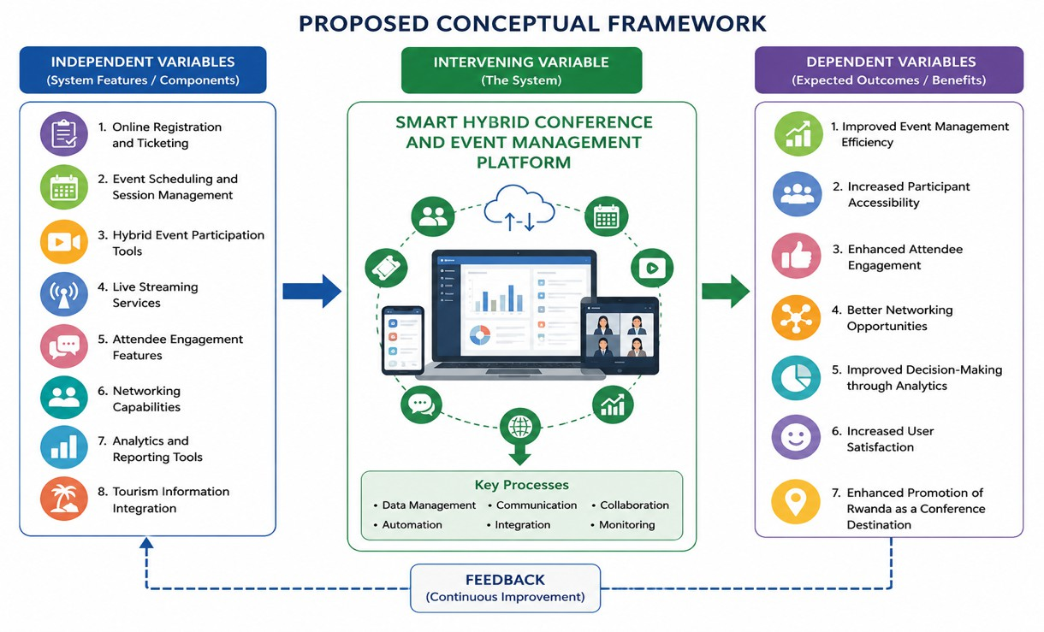
The conceptual framework assumes that the implementation of online registration, event scheduling, hybrid participation tools, live streaming services, engagement features, networking capabilities, analytics, and tourism integration through the Smart Hybrid Conference and Event Management Platform will positively influence conference management outcomes.

Figure 1

CHAPTER THREE: RESEARCH METHODOLOGY

3.0 Introduction

Chapter Three presents the research methodology employed in conducting this study. Research methodology refers to the systematic procedures, techniques, and approaches used by researchers to collect, analyze, interpret, and present data in order to achieve the objectives of a study. The selection of an appropriate methodology is essential because it ensures that the research findings are reliable, valid, and capable of addressing the research problem effectively.

3.1 Research Design

This study adopted a descriptive research design. A descriptive research design is appropriate because it enables the researcher to collect detailed information about the existing conference and event management practices, identify challenges faced by stakeholders, and determine user requirements for the proposed Smart Hybrid Conference and Event Management Platform.

The descriptive research design was selected because it allows the researcher to gather both qualitative and quantitative data from conference organizers, event participants, and other relevant stakeholders. Through this approach, the researcher was able to describe current conference management processes, examine existing problems, and propose appropriate technological solutions. Additionally, the study employed a system development research approach since the primary objective was to design, develop, and evaluate a Smart Hybrid Conference and Event Management Platform. The system development approach involved several stages, including requirements gathering, system analysis, system design, implementation, testing, and evaluation. This approach ensured that the developed system adequately addressed the identified needs and challenges within conference and event management.

3.2 Population and Selection of the sample

The selection of an appropriate population and sampling strategy ensures that the information obtained is relevant, reliable, and representative of the study objectives. In this study, data were collected from stakeholders involved in conference and event management in Rwanda in order to gather requirements for the development of the Smart Hybrid Conference and Event Management Platform.

3.2.1 Target Population

The target population includes management staff, conference and event coordinators, Information Technology (IT) personnel, marketing and communication officers, and selected conference organizers who work closely with the Rwanda Convention Bureau. These respondents were selected because they have practical knowledge of the existing conference management processes and can provide valuable information regarding the challenges, requirements, and expectations for the proposed Smart Hybrid Conference and Event Management Platform.
The target population included:

      - Conference and event organizers.
      - Event participants and attendees.
      - Conference speakers and presenters.
      - Event management staff and administrators.
      - Information Technology (IT) personnel responsible for system management.
      - Representatives from organizations that frequently host conferences and events.

The researcher selected these categories because they are the primary users and beneficiaries of the proposed Smart Hybrid Conference and Event Management Platform. Their opinions and experiences were essential in identifying existing challenges and defining the requirements for the proposed system
Table 3.1 presents the target population for the study.

Table 1: Population categories

Category of Respondents | Population Size
Management Staff | 5
Conference And evet Coordinators | 10
IT Personnel | 7
Marketing and Communication Oficers | 4
Conference Organizers/ partners | 10
Total | 36

3.2.2 Sampling selection

Sampling refers to the process of selecting a subset of individuals from the target population to participate in the study. Since studying the entire population may be time-consuming and costly, sampling enables the researcher to obtain representative data from a manageable number of respondents.
This study employed purposive sampling as the primary sampling strategy. Purposive sampling is a non-probability sampling technique in which respondents are selected based on their knowledge, experience, and involvement in the phenomenon under investigation. The purposive sampling technique was considered appropriate because the study required respondents who possess specific knowledge and experience in conference and event management. Therefore, conference organizers, event administrators, IT personnel, and frequent conference participants were intentionally selected because they could provide relevant and reliable information regarding existing conference management practices and system requirements

Table 2: Sample selection

Category of Respondents | Target Population  (N) | Sampling Technique | Sample Size  (n)
Conference/Event Organizers | 15 | Purposive Sampling | 15
Event Participants/Attendees | 40 | Simple Random Sampling | 27
Event Management Staff | 10 | Purposive Sampling | 10
IT Personnel/System Administrators | 10 | Purposive Sampling | 10
Conference Speakers | 5 | Purposive Sampling | 5
Total | 80 | — | 67

3.3 Tools for Data Collection and Instrumentation

Data collection tools and instrumentation refer to the instruments and techniques used by researchers to gather relevant information from respondents. The selection of appropriate data collection tools is essential because it ensures that accurate, reliable, and comprehensive data are obtained to address the research objectives. In this study, both quantitative and qualitative data collection tools were employed to gather information regarding the requirements, challenges, and expectations associated with conference and event management.

3.4 Collection of data

For this research on the development of a Smart Hybrid Conference Platform, data was collected from event organizers, conference attendees, ICT professionals, and other relevant stakeholders. The purpose of collecting data was to identify user requirements, understand existing challenges in conference management, and gather recommendations for the proposed system

The data collection process followed the steps below:

Step 1: Identification of Respondents

Step 2: Preparation of Data Collection Instrument

Step 3: Data Collection

Step 4: Recording and Organization of Data

Step 5: Data Verification

Step 6: Data Analysis Preparation

After verification, the data was prepared for analysis. Quantitative data was summarized using statistical techniques such as frequencies and percentages, while qualitative data was grouped into themes and interpreted according to the study objectives.

Data Gathering Flow: Identification of Respondents → Preparation of Instruments → Data Collection → Data Recording and Organization → Data Verification → Data Analysis Preparation

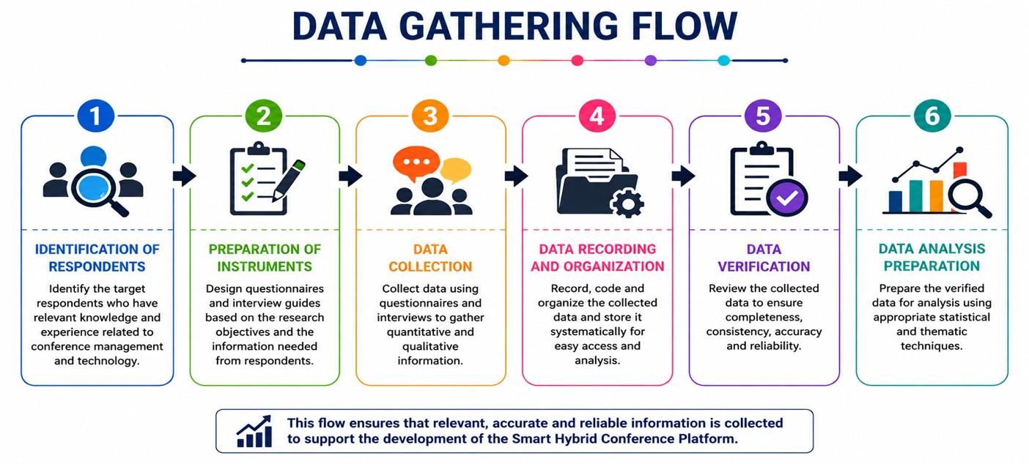
Figure 2

3.5 Presentation of data and Analysis of data

Presentation and analysis of data involve organizing, summarizing, interpreting, and presenting the information collected during the research process. This enables the researcher to draw meaningful conclusions and make informed recommendations regarding the development of the Smart Hybrid Conference Platform.
Quantitative data obtained through questionnaires will be coded, tabulated, and analyzed using descriptive statistical methods. The analysis will focus on determining frequencies, percentages, and distributions of responses.
The percentage of respondents for each response category will be calculated using the following formula:
𝑃 = 𝐹 × 100
𝑁
Where:
P = Percentage F = Frequency of respondents N = Total number of respondents

The results will be presented using: Frequency tables, Percentage tables, Bar charts, Pie charts, Graphs
This analysis will provide deeper insights into stakeholder expectations and challenges associated with conference management and hybrid event platforms.

Data Collection → Data Coding → Data Classification → Data Analysis → Data Presentation
→ Interpretation of Findings → Conclusion and Recommendations
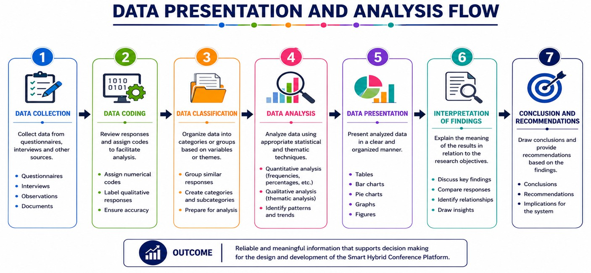

Figure 3

3.6 Validity and Reliability

The quality of research findings depends largely on the validity and reliability of the instruments used for data collection. Therefore, before the actual data collection process, the researcher ensured that the research instruments were both valid and reliable. This was done to guarantee that the information collected accurately reflected the research objectives and produced consistent results.

Validity of Research Instruments; In this study, content validity was used to determine the appropriateness of the questionnaire and interview guide. The research instruments were prepared based on the study objectives, research questions, and literature review. The draft instruments were then presented to the research supervisor and other experts in Information Technology and research methodology for review.

Reliability of Research Instruments; To determine the reliability of the questionnaire, a pilot study was conducted involving a small group of respondents who possessed characteristics similar to those of the actual study participants but were not included in the final sample. The purpose of the pilot study was to evaluate the clarity, consistency, and effectiveness of the questionnaire. Any questions that were found to be unclear or inconsistent during the pilot study were revised before the final administration of the questionnaire. This process ensured that the research instruments produced accurate and consistent data throughout the study. By ensuring both validity and reliability, the researcher enhanced the credibility, accuracy, and trustworthiness of the research findings. Consequently, the data collected were considered suitable for analyzing the requirements and developing the proposed Smart Hybrid Conference and Event Management Platform.

3.7 Ethical Considerations

Ethical considerations are important in ensuring that the research is conducted responsibly, professionally, and with respect for the rights of participants. In this study on the development of a Smart Hybrid Conference Platform, the researcher will adhere to ethical principles throughout the data collection, analysis, and reporting processes.

Informed Consent; Before collecting data, participants will be informed about the purpose of the study, the nature of their involvement, and how the collected information will be used. Participation will be voluntary, and respondents will be required to provide their consent before taking part in the research.

Confidentiality; The researcher will ensure that all information provided by respondents remains confidential. Personal details and responses will not be disclosed to unauthorized individuals, and the data will be used strictly for academic purposes related to this study.

Anonymity; To protect the identity of participants, respondents will not be required to provide personal information that could directly identify them unless necessary. Any information collected will be reported in a manner that does not reveal individual identities.

Voluntary Participation; Participants will have the right to choose whether or not to participate in the study. They will also be free to withdraw from the research at any stage without any penalty or negative consequences.

Data Protection and Security; The researcher will take appropriate measures to ensure the security of collected data. Electronic records will be stored securely using password-protected devices and files, while any physical documents will be kept in safe locations accessible only to the researcher.

Honesty and Integrity; The researcher will ensure that all information collected and presented is accurate and truthful. Data will not be manipulated, fabricated, or misrepresented. Findings and conclusions will be reported objectively based on the evidence obtained during the study.

Respect for Participants
All respondents will be treated with respect, fairness, and dignity throughout the research process.

The researcher will avoid any form of discrimination, coercion, or actions that may cause harm, discomfort, or inconvenience to participants.

Use of Data for Academic Purposes Only; The information collected during the study will be used solely for academic and research purposes. The data will not be shared, sold, or used for any personal, commercial, or unauthorized activities.

REFERENCES
- Annual Report 2023. Rwanda Convention Bureau,
- Kalulu, R., Aransiola, A. S., & Abel, C. (2022). Rwanda MICE Strategy and Its Influence on the Tourism Industry: Case Study of Rwanda Convention Bureau. African Journal of Tourism and Hospitality Management, 1(1), 15–32.
- Bertalanffy, L. V. (1968). General system theory: Foundations, development, applications. George Braziller.
- Creswell, J. W., & Creswell, J. D. (2018). Research design: Qualitative, quantitative, and mixed methods approaches (5th ed.). SAGE Publications.
- Davis, F. D. (1989). Perceived usefulness, perceived ease of use, and user acceptance of information technology. MIS Quarterly, 13(3), 319–340.
- DeLone, W. H., & McLean, E. R. (2003). The DeLone and McLean model of information systems success: A ten-year update. Journal of Management Information Systems, 19(4),
& Page, S. J. (2016). Event studies: Theory, research and policy for planned events (3rd ed.). Routledge.
- Hair, J. F., Black, W. C., Babin, B. J., & Anderson, R. E. (2019). Multivariate data analysis (8th ed.). Cengage Learning.
- Kim, D. Y., Jang, S., & Morrison, A. M. (2011). Factors affecting organizational information technology acceptance: A comparison of convention and visitor bureaus and meeting planners in the United States. Journal of Convention & Event Tourism, 12(1), 1–24.
- Laudon, K. C., & Laudon, J. P. (2020). Management information systems: Managing the digital firm (16th ed.). Pearson Education.
- O'Leary, Z. (2021). The essential guide to doing your research project (4th ed.). SAGE Publications.
- Page, S. J., & Connell, J. (2020). Tourism: A modern synthesis (5th ed.). Routledge.
- Rogers, E. M. (2003). Diffusion of innovations (5th ed.). Free Press.
- Sangkaew, P., Jago, L., & Gkritzali, A. (2019). Adapting the technology acceptance model for business events: The event organizer perspectives. Event Management, 23(6), 773–788.
- Talantis, S., Shin, Y. H., & Severt, K. (2020). Conference mobile application: Participant acceptance and the correlation with overall event satisfaction utilizing the technology acceptance model (TAM). Journal of Convention & Event Tourism, 21(2), 100–122.
- Thomas, K., & Stephens, S. (2022). Understanding the management theory in event management: A conceptual framework. Event Management.
- Yin, R. K. (2018). Case study research and applications: Design and methods (6th ed.). SAGE Publications.
- Allen, J., O'Toole, W., Harris, R., & McDonnell, I. (2022). Festival and special event management (7th ed.). Wiley.
- Bowdin, G., Allen, J., O'Toole, W., Harris, R., & McDonnell, I. (2018). Events management (4th ed.). Routledge.

